**“The Safety of Women’s (FemmeFortress)”**

**A Project Report Submitted to**



**MVP’s**

**Institute of Management, Research & Technology [I.M.R.T.]**

**MVP Campus, Gangapur Road, Nashik**



**For the Degree of Master in Business Administration**

**MBA (Information Technology)**

In the Subject of

**Software Development**

SUBMITTED BY:

**WADNERKAR ANUSHREE SANJAY**

Roll No. / Seat No.

58/

**UNDER THE GUIDENCE OF  
PROF R.L.PAGAR**

**Dept. of Computer Management**

**Institute of Management, Research & Technology**

**[I.M.R.T], Nashik-2**

**YEAR 2023-24**

**ACKNOWLEDGEMENT**

I'm taking this opportunity to extend my heartfelt gratitude to all those who supported me throughout my MBA (IT) project journey. Their guidance, constructive criticism, and friendly advice were invaluable, helping me navigate through the challenges of the project. I am genuinely thankful for their candid and enlightening perspectives on various project-related issues.

Today marks a significant milestone as I present the project report on the Web-based application of "The Safety of Women’s (FemmeFortress)". I extend my sincere thanks to Mrs. Nilam Bodke Mam for their unwavering support and guidance at Sumago Infotech Pvt. Ltd.

I am grateful to Dr. P.B. Suryawanshi, the director of the Institute of Management Research and Technology, Nashik-2, for his cooperation and permission to undertake this MBA-IT project.

I would also like to express my gratitude to my project's external guide from Sumago Infotech Pvt. Ltd. and all those who provided the necessary facilities and conducive conditions for my MBA-IT project.

I take this moment to extend my sincere thanks to my internal guide, Prof. R. L. Pagar, for his kind cooperation throughout the project. His guidance has been instrumental in completing this project. His advice, insights, and ideas have kept me on the right path.

I also extend my thanks to the staff of the IT Department at L.M.R.T. Nashik, especially Prof. R. L. Pagar (H.O.D), for their valuable guidance during the project's development and for constantly encouraging me.

Last but not least, I extend my heartfelt thanks to all my friends and colleagues who supported me throughout the project. Their support, encouragement, and cheerful demeanor were indispensable, without which our project might not have reached completion.

Thank you…!

Date: / /2024 Anushree Sanjay Wadnerkar

Place: I.M.R.T. Nashik. (ΜΒΑ-ΙΤ-II)

**INDEX**

|  |  |  |
| --- | --- | --- |
| **Sr. No** | **Particulars** | **Page No.** |
|  | **Acknowledgement** |  |
| **1.** | **Introduction** |  |
| 1.1 | Introduction (Selection of the topic) |  |
| 1.2 | Objectives of the study |  |
| 1.3 | Scope of the study |  |
| 1.4 | Proposed System |  |
| 1.5 | Limitations of the study |  |
| **2.** | **Project Methodology/System Analysis** |  |
| 2.1 |  |  |
| 2.2 |  |  |
| 2.3 |  |  |
| **3.** | **Profile of the Organization** |  |
| 3.1 | History & General Information |  |
| 3.2 | Organization |  |
| 3.3 | Products/Activities |  |
| 3.4 | Corporate & Functional Practices |  |
| **4.** | **System Design** |  |
| 4.1 | Meaning & Concepts of the Topic |  |
| 4.2 | Basic Theories of the Topic |  |
| 4.3 | Basic ideas of the Project Topic |  |
| **5.** | **System Implementation** |  |
| 5.1 | Coding |  |
| **6.** | **Conclusion** |  |
| **7.** | **Future Enhancement** |  |
| **8.** | **Bibliography** |  |

1. **INTRODUCTION**

**DUCTION**

**Introduction**

"FemmeFortress" is a combination of two words: "femme," which is French for woman, and "fortress," which refers to a fortified structure or stronghold. In essence, "FemmeFortress" symbolizes a stronghold and dedicated to the safety, empowerment, and protection of women. It conveys the idea of a secure and supportive environment where women can feel safe, empowered, and well-supported. The term encapsulates the mission of the web-based application it represents, emphasizing its commitment to ensuring the safety and well-being of women.

"FemmeFortress" is a web-based application developed using the MERN stack technology, comprising MongoDB, Express.js, React.js, and Node.js. It serves as a dedicated platform for ensuring the safety and well-being of women within our institute, embodying empowerment and security.

Through FemmeFortress, we provide an immediate complaint facility for both students and staff. Users can register and log in to access the complaint submission feature, allowing them to voice their concerns promptly. These complaints are then efficiently directed to the institute's director or mentor for resolution, ensuring prompt responses and diligent handling of every issue raised.

Security is a top priority in FemmeFortress. The platform employs role-based access control to ensure that only authorized personnel can view and edit specific information. Additionally, encryption techniques are utilized to safeguard sensitive data, protecting the privacy of users.

FemmeFortress utilizes the latest MERN stack technology to ensure a robust, scalable, and secure platform for facilitating this crucial service. With its user-friendly interface and agile functionality, FemmeFortress stands as a testament to our commitment to fostering a safe and supportive environment for women within our institution.

**Objectives of the study**

1. Ensure the safety and well-being of women within the institute by providing a dedicated platform for reporting concerns and seeking assistance promptly.
2. Empower women by offering an immediate complaint facility that allows them to voice their concerns promptly and effectively.
3. Provide real-time notifications and updates to students regarding the status of their complaints, enhancing transparency and accountability.
4. Streamline the complaint submission process by providing a user-friendly interface for registration and login, allowing users to submit complaints efficiently.
5. Direct complaints to the institute's director or mentor for prompt resolution, ensuring that every issue raised is handled diligently and with urgency.
6. Establish secure data handling mechanisms to protect the confidentiality and privacy of user information.
7. Prioritize security by implementing role-based access control and encryption techniques to protect sensitive user data and ensure the privacy of users.
8. Maintain transparency in the complaint resolution process, providing users with updates on the progress and resolution of their complaints.
9. Foster a supportive environment for women within the institute by actively addressing and resolving their concerns through FemmeFortress.

**Scope of the study**

1. Develop a comprehensive system for managing and tracking complaints submitted by students and staff regarding safety and well-being issues within the institute.
2. Implement secure registration, login, and role-based access control mechanisms to ensure that only authorized users can submit complaints and access sensitive information.
3. Design and implement an efficient workflow for handling complaints, including routing complaints to the appropriate authorities for prompt resolution and feedback mechanisms for users to track the status of their complaints.
4. Ensure the implementation of encryption techniques and other security measures to safeguard sensitive user data, such as personal information and complaint details, thus maintaining the privacy and confidentiality of users.
5. Explore and implement the MERN stack technology stack, including MongoDB, Express.js, React.js, and Node.js, to develop a scalable and secure web-based application.

**Proposed System**

The proposed system for FemmeFortress involves creating a seamless process for users to submit complaints and have them addressed promptly and efficiently. Upon accessing the web-based application, users, including students and staff, will undergo a registration process to establish their identities within the system. Once registered, they can log in to access the complaint submission feature.

This feature will be designed with user-friendliness in mind, ensuring that users can easily articulate their concerns and submit them with minimal effort. Behind the scenes, the system will employ role-based access control mechanisms, allowing only authorized personnel, such as administrators and mentors, to view and manage complaints.

When a complaint is submitted, it will follow a predefined workflow for resolution. This workflow will ensure that each complaint is promptly directed to the appropriate authority within the institute, such as the director or designated mentor. These individuals will then be responsible for addressing the complaint with diligence and urgency.

To maintain the security and privacy of user data, the system will utilize encryption techniques to safeguard sensitive information. This will ensure that personal details and complaint details remain confidential and protected from unauthorized access.

From a technical standpoint, the system will be developed using the MERN stack technology, comprising MongoDB, Express.js, React.js, and Node.js. This choice of technology will ensure that the platform is robust, scalable, and easy to maintain. Regular updates and maintenance will be conducted to address any security vulnerabilities or technical issues that may arise.

**Limitations of the study**

1. The project's abilities and growth might be limited by the technology it's built with. If the tools and software aren't powerful enough, it could hold back what FemmeFortress can do.
2. Encouraging everyone to use FemmeFortress might be tricky. If students and staff aren't keen on using it or aren't comfortable reporting issues online, it could slow things down.
3. If there's not enough money or people to support FemmeFortress, it might struggle. Without proper funding and staff, it could be tough to keep everything running smoothly.
4. Even with security measures, some people might worry about their privacy. If users don't trust FemmeFortress to keep their information safe, they might not use it as much.
5. If the school or organization doesn't fully support FemmeFortress, it might not reach its full potential. Without strong backing from leaders and stakeholders, it could be hard to make it work effectively.

**2. PROJECT METHODOLOGY**

**Method of Study**

**3. PROFILE OF THE ORGANIZATION**

**History & General Information**

At Sumago Infotech, they are committed to providing top-notch IT services that empower their business to thrive in the digital age. Their comprehensive range of services is designed to address the evolving needs of modern enterprises.

Sumago Infotech adopts a project development philosophy centered on client satisfaction and excellence in service delivery. Drawing from extensive industry experience, Sumago Infotech emphasizes a holistic approach to addressing the evolving needs of modern enterprises. Their dedicated team of skilled professionals is committed to understanding each client's unique goals and challenges, ensuring that solutions are tailored to meet specific requirements effectively. By prioritizing a client-centric approach, Sumago Infotech fosters collaborative partnerships, driving successful project outcomes.

Sumago Infotech offers a comprehensive suite of IT services, encompassing a wide range of capabilities to address the diverse needs of modern enterprises. Their expertise spans across various domains, including web development, mobile application development, digital marketing, IT consulting, IT solutions, project management, data analytics, resource augmentation, blockchain, artificial intelligence (AI), outsourcing engagement, and IoT (Internet of Things).

**Mission:**

At Sumago Infotech, we strive with technology to provide the most effective and affordable services that fulfill our customers' needs and budgets. We provide customized websites and software solutions that suit our customers' company objectives. We always involve our customers in the entire process, starting from design right up to deployment, so that your ideas can be incorporated into our work.

[](https://web.sumagoinfotech.com/)

**Organization**

**Nature/Scope/Structure:**

Sumago Infotech embodies the essence of a friendly and inclusive organizational culture. Their commitment to celebrating various festivals with employees' highlights their emphasis on fostering a warm and welcoming work environment. This friendly nature is reflective of an organizational culture that values camaraderie, teamwork, and employee well-being. By recognizing and celebrating cultural and personal milestones, Sumago Infotech creates a sense of belonging and friendship among its team members. This culture of inclusivity and friendliness not only promotes employee morale and engagement but also cultivates a positive and collaborative atmosphere conducive to innovation and success. Overall, Sumago Infotech's organizational culture is characterized by its friendly and supportive nature, where employees feel valued, appreciated, and encouraged to thrive.

**Product/Activities**

**Sumago Infotech offer services for…**

* **Healthcare**
* **Travel & Hospitality**
* **Finance & Banking**
* **E-commerce**
* **Manufacturing**
* **Education**
* **Government**
* **Retail**
* **Logistic**

**Corporate & Functional Practices**

**Web Development:**

Website and web application development, upkeep, and enhancement are all included in web development services. This includes developing the front-end and back-end components, creating the user interface and graphic components, and publishing the website to the internet. In order to guarantee that websites run successfully, these services also include hosting, security, and performance optimization. We create simple websites as well as intricate e-commerce platforms and web-based applications in collaboration with clients to satisfy their demands.

**Mobile Application:**

The process of developing software applications for mobile devices, such as smartphones and tablets, is known as mobile application development. It includes testing, deployment, coding, and user interface design. Programming languages like Java, Swift, or Kotlin are used by developers, based on the platform they are targeting (iOS or Android). Testing and quality control are crucial to ensuring the software runs smoothly. To safeguard user data and privacy, security methods including data encryption and authentication are essential. Apps are usually released through app stores like Google Play or Apple's App Store after they have been developed

**Digital Marketing:**

Social media marketing uses platforms like Facebook, Instagram, and Twitter to buildbrand awareness and interact with customers. Email marketing involves sending targeted messages to subscribers to nurture leads and drive conversions. Pay-per-click (PPC) advertising allows businesses to pay for their ads to appear at the top of search engine results or on social media Digital marketing services provide businesses with the tools to reach a broader audience, build brand recognition, and measure the effectiveness of their online marketing efforts

**Project Management:**

Project management is the discipline of planning, executing, and controlling projects efficiently. It often involves agile methodologies for adaptability, quality assurance to ensure deliverables meet predefined standards, and risk management to identify and mitigate potential project challenges, all aimed at ensuring project success

**Data Analytics:**

Data analytics is the process of analyzing and investigating data to draw insightful conclusions. This comprises data warehousing for effective data storage, data governance to uphold data quality and compliance, predictive analytics to anticipate future outcomes, big data solutions to handle massive and complex datasets, and data analytics for identifying patterns and trends.

**Blockchain:**

Blockchain technology enables safe and transparent transactions by acting as a decentralized, unchangeable ledger. Services in this area include the creation and management of unique tokens and cryptocurrencies, the development of blockchain-based applications for a range of uses, and professional advice on implementing blockchain to improve trust and transparency in sectors such as finance, supply chains, and healthcare

**Artificial Intelligence (AI):**

The creation of AI-powered applications with task automation and prediction capabilities is included in AI services. This includes computer vision for image analysis, natural language processing (NLP) for language understanding and processing, machine learning to train models for particular tasks, and AI consultancy to assist businesses in utilizing AI for productivity and data-driven decision-making.

**IT Solutions:**

IT solutions include the thoughtful planning, development, and use of technological solutions to match the unique requirements of an enterprise. It includes system integration to optimize operations, cybersecurity measures to safeguard digital assets, cloud services for scalable and affordable solutions, custom software development for customized applications, system integration to evaluate current infrastructure and plan future strategies, and continuous support for seamless IT management.

**Meaning & Concept of the Topic**

**4. SYSTEM DESIGN**

"FemmeFortress" suggests a protective stronghold specifically designed for women. "Femme" refers to women, emphasizing femininity, while "Fortress" signifies a place of safety and security. Together, "FemmeFortress" conveys the concept of a robust and secure environment tailored to the needs and concerns of women. It implies a space where women can feel empowered, supported, and protected, whether it be physically, emotionally, or socially.

FemmeFortress represents more than just a technological platform; it stand for a commitment to creating a safe and inclusive environment where women can grow without fear of harassment or violence. By leveraging the capabilities of ReactJS, FemmeFortress offers a user-friendly interface that facilitates seamless access to essential safety features, such as incident reporting, emergency assistance, and educational resources.

**Basic Theories of the Topic**

What is UML?

**Unified Modeling Language (UML)** is a general-purpose modeling language. The main aim of UML is to define a standard way to **visualize** the way a system has been designed. It is quite similar to blueprints used in other fields of engineering. UML is**not a programming language.**

* We use UML diagrams to portray the behavior and structure of a system.
* UML helps software engineers, businessmen, and system architects with modeling, design, and analysis.
* Complex applications need collaboration and planning from multiple teams and hence require a clear and concise way to communicate amongst them.
* Businessmen do not understand code. So UML becomes essential to communicate with non-programmers about essential requirements, functionalities, and processes of the system.
* A lot of time is saved down the line when teams can visualize processes, user interactions, and the static structure of the system.

Different Types of UML Diagrams

### [**Class Diagram**](https://www.geeksforgeeks.org/unified-modeling-language-uml-class-diagrams/):

The most widely use UML diagram is the class diagram. It is the building block of all object oriented software systems. We use class diagrams to depict the static structure of a system by showing system’s classes, their methods and attributes. Class diagrams also help us identify relationship between different classes or objects.

1. **Activity Diagram:**

We use Activity Diagrams to illustrate the flow of control in a system. We can also use an activity diagram to refer to the steps involved in the execution of a use case.

* We model sequential and concurrent activities using activity diagrams. So, we basically depict workflows visually using an activity diagram.
* An activity diagram focuses on condition of flow and the sequence in which it happens.
* We describe or depict what causes a particular event using an activity diagram.

1. **Use Case Diagram:**

Use Case Diagrams are used to depict the functionality of a system or a part of a system. They are widely used to illustrate the functional requirements of the system and its interaction with external agents (actors).

* A use case is basically a diagram representing different scenarios where the system can be used.
* A use case diagram gives us a high level view of what the system or a part of the system does without going into implementation details.

1. **Sequence Diagram:**

A sequence diagram simply depicts interaction between objects in a sequential order i.e. the order in which these interactions take place.

* We can also use the terms event diagrams or event scenarios to refer to a sequence diagram.
* Sequence diagrams describe how and in what order the objects in a system function.
* These diagrams are widely used by businessmen and software developers to document and understand requirements for new and existing systems.

1. **Component Diagram:**

Component diagrams are used to represent how the physical components in a system have been organized. We use them for modelling implementation details.

* Component Diagrams depict the structural relationship between software system elements and help us in understanding if functional requirements have been covered by planned development.
* Component Diagrams become essential to use when we design and build complex systems.
* Interfaces are used by components of the system to communicate with each other.

1. **Deployment Diagram:**

Deployment Diagrams are used to represent system hardware and its software.It tells us what hardware components exist and what software components run on them.

* We illustrate system architecture as distribution of software artifacts over distributed targets.
* An artifact is the information that is generated by system software.
* They are primarily used when a software is being used, distributed or deployed over multiple machines with different configurations.

**Basic ideas of the Project**

**Activity Diagram:**

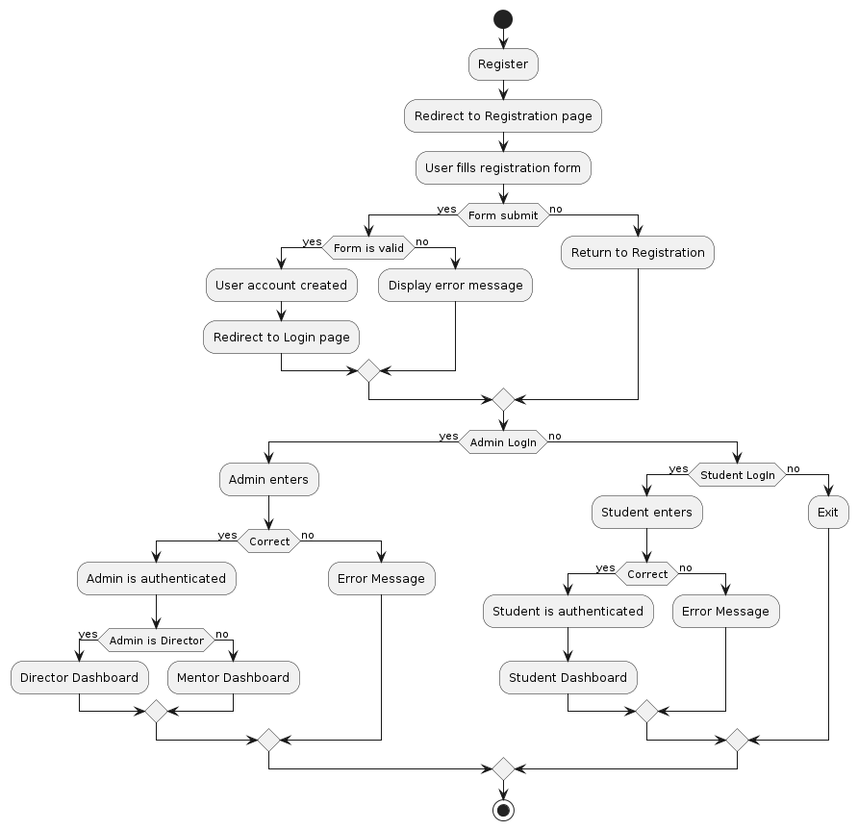

**Use Case Diagram:**

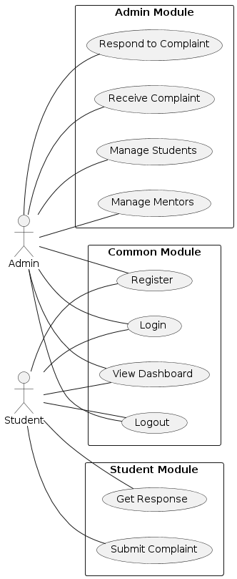

**Sequence Diagram:**

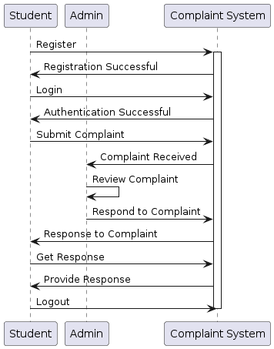

**Component Diagram:**

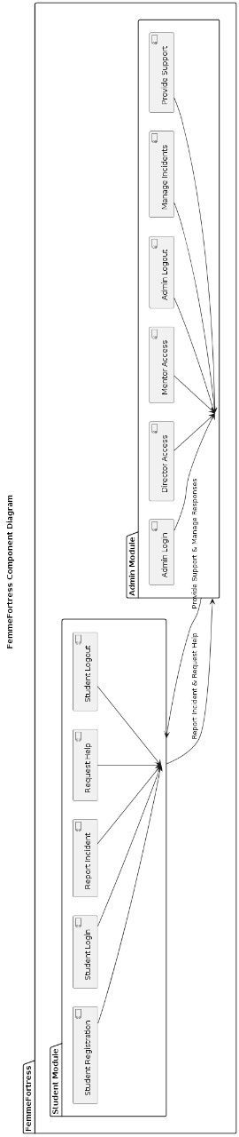

**Deployment Diagram:**

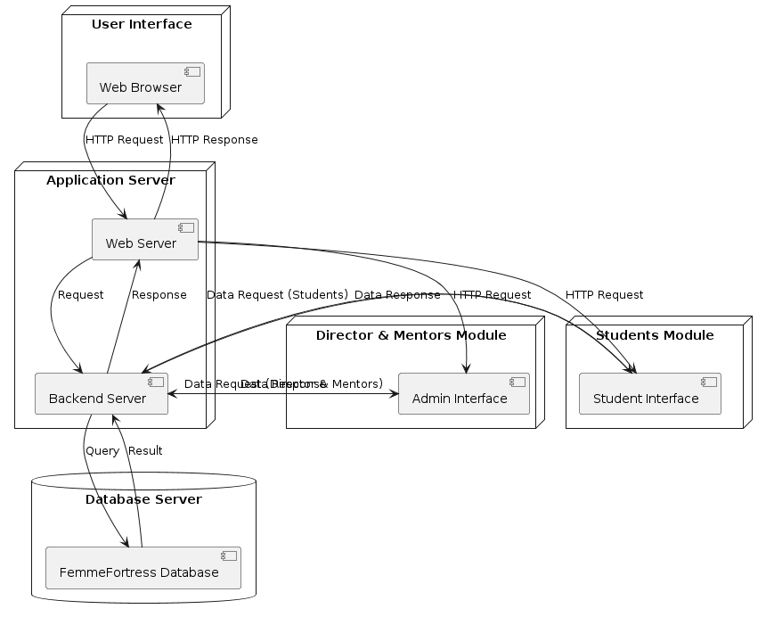

**Coding**

**5. SYSTEM IMPLEMENTATION**

**Database Designing**

**Sample of Coding**

**Sample Interfaces:**

**Input/Output Screens**

**6. CONCLUSION**

**Conclusion**

**7. FUTURE ENHANCEMENT**

**Future Enhancement**

**8. BIBLIOGRAPHY**

**Bibliography**